IBM – Nutrition Assistant Application

Assignment – 4

KANISKA VARSINI P D

19Z222

IV BE CSE G1

|  |  |
| --- | --- |
| Date | 12 November 2022 |
| Team ID | PNT2022TMID12518 |
| Project Name | Project – Nutrition Assistant Application |
| Maximum Marks | 8 Marks |

1) Pull an Image from docker hub and run it in docker playground.

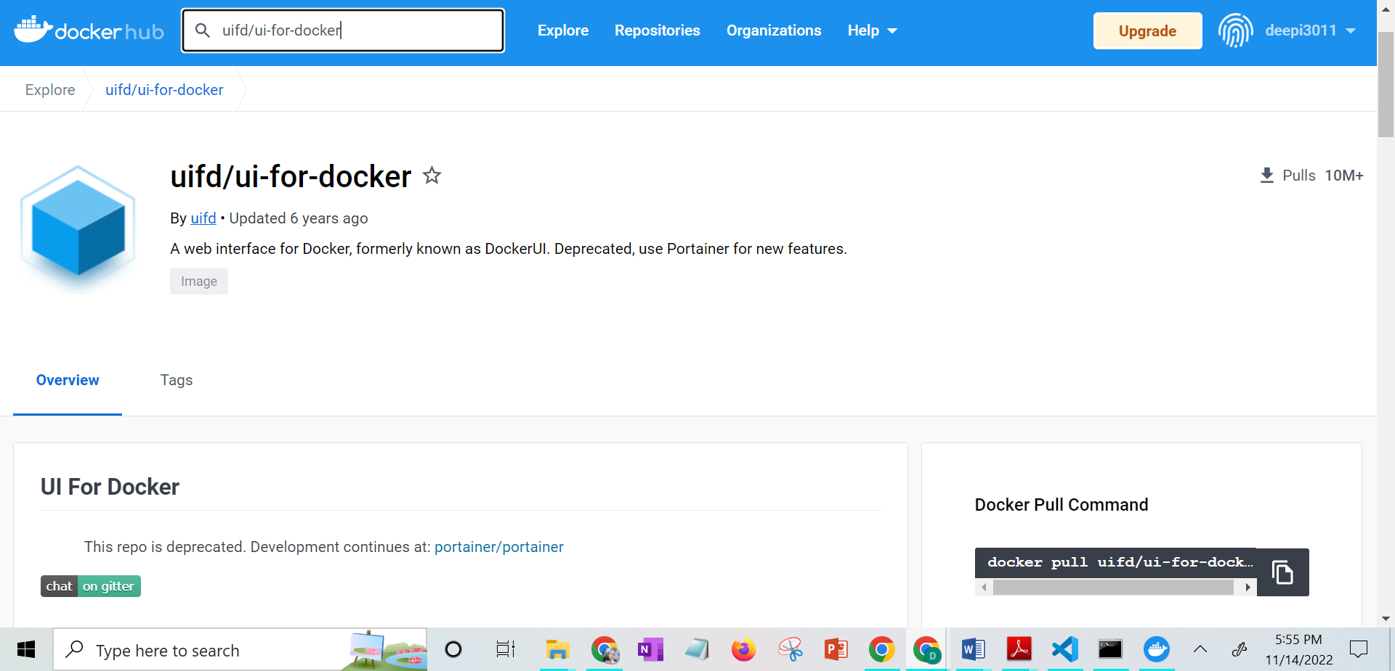

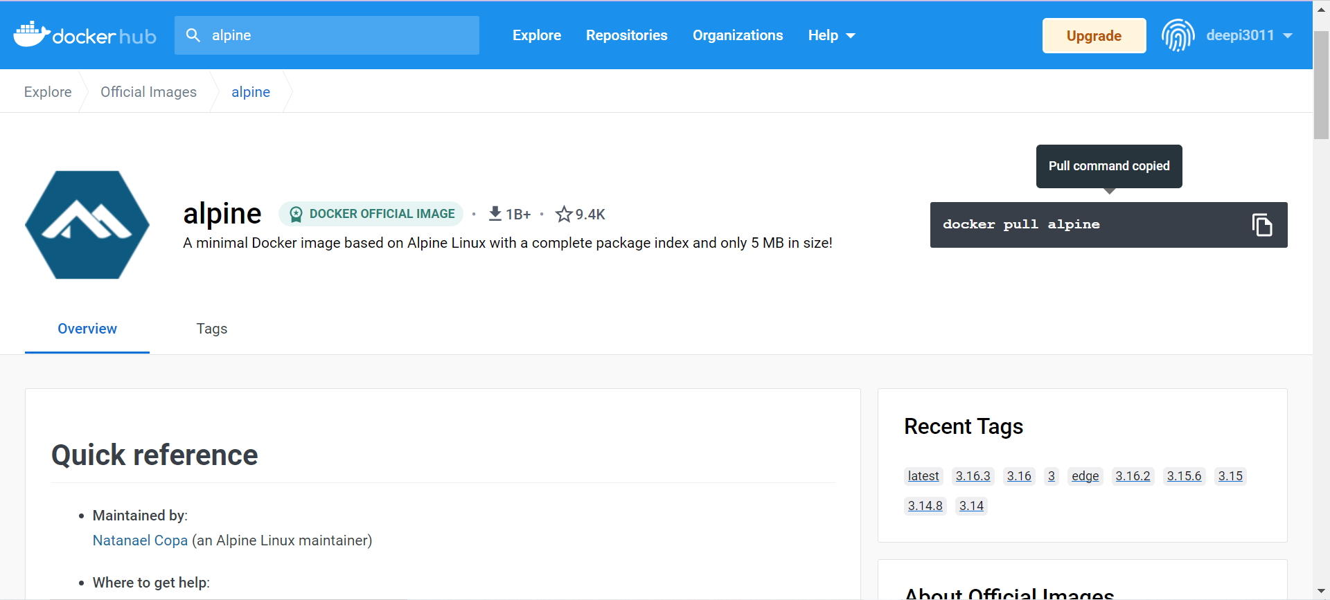

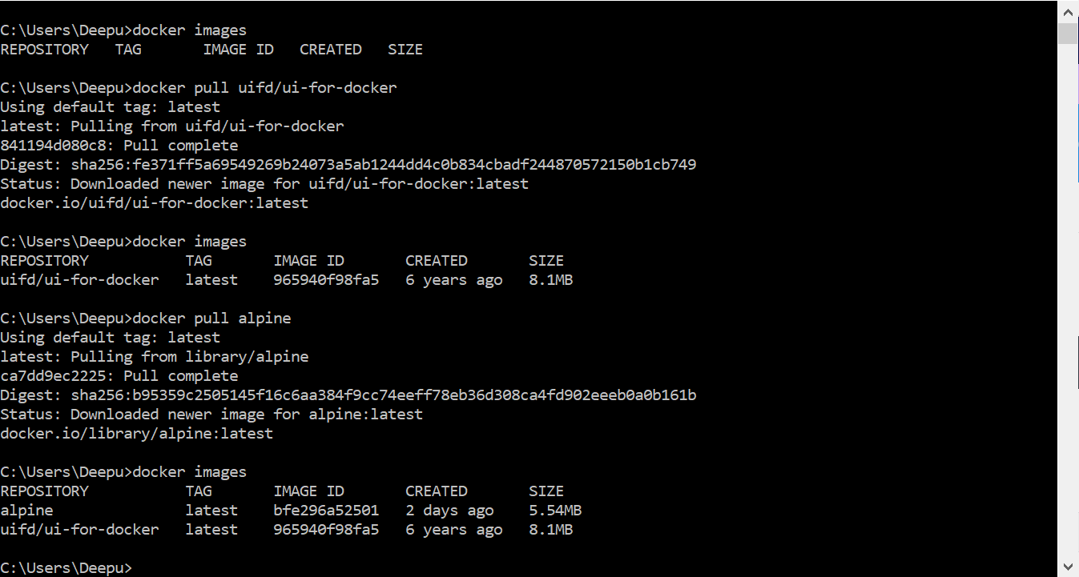

2) Create a docker file for the jobportal application and deploy it in Docker desktop application.

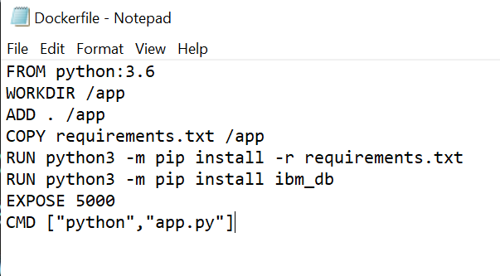

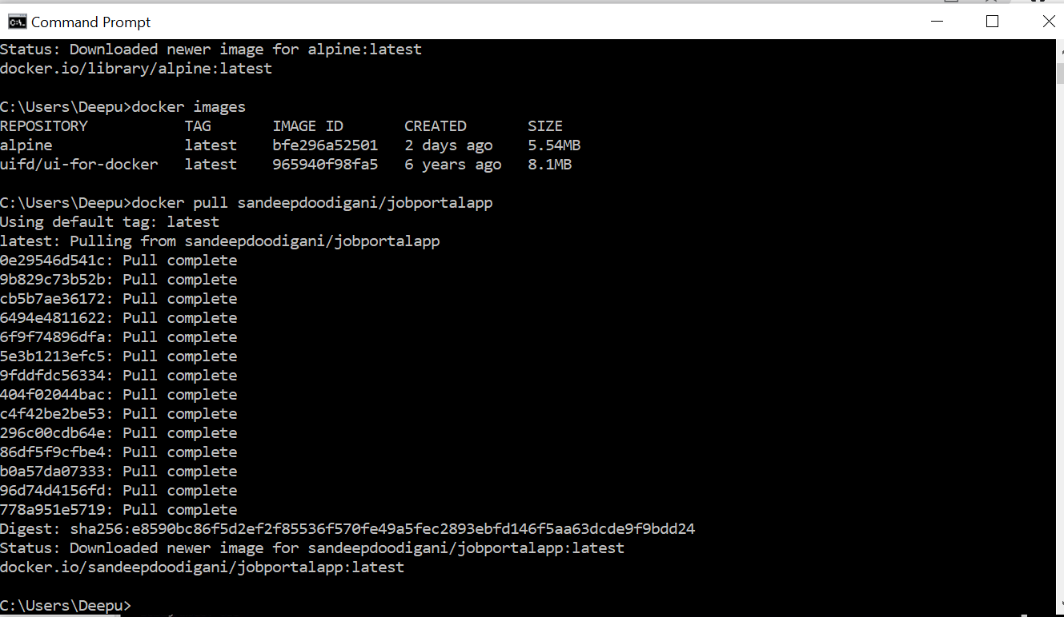

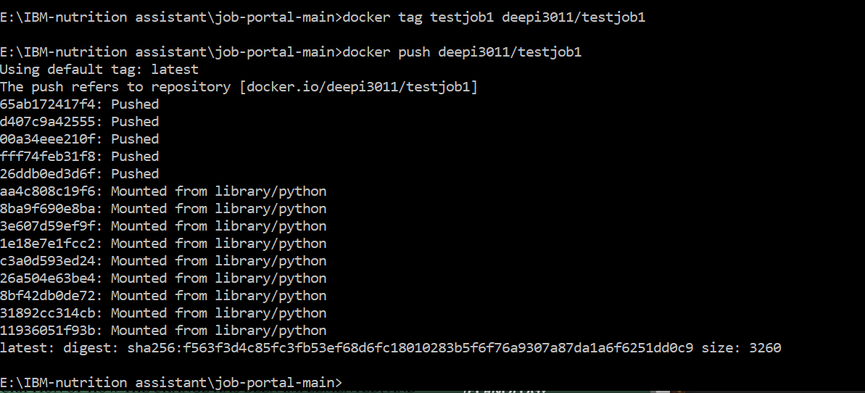

3.Create a IBM container registry and deploy helloworld app or jobportalapp.

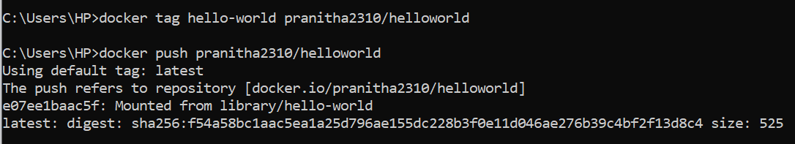

4.Create a Kubernetes cluster in IBM cloud and deploy helloworld image or jobportal image and also expose the same app to run in nodeport.

